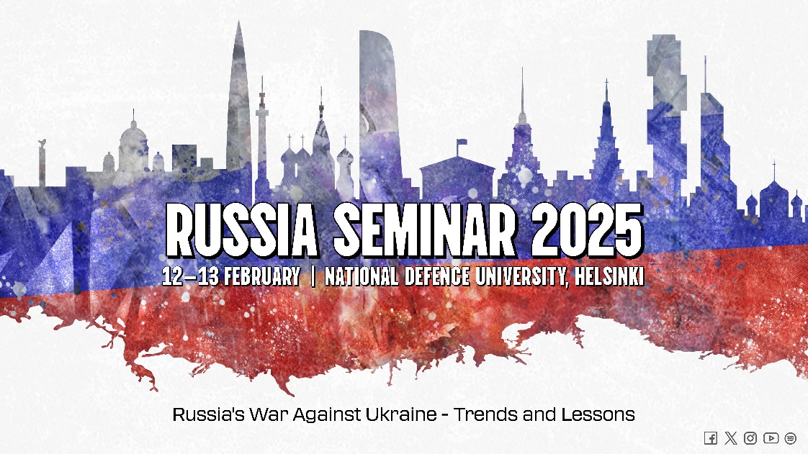
Russia’s War Against Ukraine
- Trends and Lessons
12-13 FEB 2025
Program (Draft 13 JAN 2025)

DAY 1 | Wednesday 12 FEB 2025
08.00-08.30 | Morning coffee
08.30-08.40 | Day 1: Welcome and Admin remarks (Itälinnake) | Janne Pukkila (FNDU)
08.40-08.45 | Opening words | Mika Kalliomaa, Rector of FNDU
 | Keynote (Itälinnake) | Janne Pukkila (FNDU)
09.00-09.30 | The Russian military’s lessons learned from the Ukraine conflict: What should concern NATO? | Rod Thornton and Marina Miron (Defence Studies Department of King’s College, UK)
09.30-09.45 | Panel
09.45-09.55 | Break
 | SESSION I (Itälinnake)  Military strategy and operational art | Katri Pynnöniemi (FNDU) |  | SESSION III (Riviera, 2nd floor)  Russia’s relations in contemporary world | Michael R. Rouland (EUCOM RSI, USA)
09.55-10.35 | AI-Augmented Analysis of Russia’s Self-Perceived Military Strengths and Weaknesses in the Russian-Ukrainian War (2022-...) | Stephan De Spiegeleire (The Hague Center for Strategic Studies, Netherlands) and Adam Stulberg (Sam Nunn School of International Affairs, Georgia Institute of Technology, Atlanta, GA, USA) | 09.55-10.25 | Changing the International Cooperation Vector of Russia to Achieve Goals in the War with Ukraine. | Valerii Hordiichuk and Nina Andrianova (NDU, Ukraine)
10.35-11.15 | Full scale invasion of Ukraine and lessons learned for NGW theory (ZOOM) | Olexander Hryb (HQ JFC NATO, Brunssum, Netherlands ) | 10.25-10.50 | Tools and mechanisms of Russia's alliance-building strategy after the outbreak of war in Ukraine: major achievements and miscalculations. | Sergei Melkonian; (Research Fellow APRI Armenia)
10.35-11.15 |  | Olexander Hryb (HQ JFC NATO, Brunssum, Netherlands ) | 10.50-11.15 | The changing role of Russia in Central Asia | Marzia Cimmino (FNDU)
11.15-11.45 | Panel |  | 11.15-11.45 | Panel
11.45-12.15 | Coffee break (30min) |  |  | Coffee break (30min)
 | SESSION II (Itälinnake)  Russia’s relations and resources | Juha-Matti Lehtonen (FNDU) |  | SESSION IV (Riviera, 2nd floor)  Russian military thought | Pentti Forsström (FNDU)
12.15-12.45 | Russian economy on war footing - A new reality financed by commodity exports | Yuriy Gorodnichenko (University of California – Berkeley); Iikka Korhonen, (BOFIT, Bank of Finland); Elina Ribakova (Peterson Institute of International Economics and Kyiv School of Economics) |  | What is new in the proposed changes in Russia’s nuclear doctrine? | Kristina Melin (FOI, Sweden)
12.45-13.15 | How Russian economy fuels its military capabilities? | Pakholchuk Vadym (Military Academy, Kyiv, Ukraine) |  | Russian Nuclear Deterrence Concept: Changes and Threats (ZOOM) | Andrii Ivachenko and Tatiana Uvarova (NDU, Ukraine)
13.15-13.45 | Panel |  |  | Panel
13.45-14.30 | Lunch (45min) |  |  | Lunch (45min)
 | SESSION V (Itälinnake)  Russia’s resources | Juha-Matti Lehtonen (FNDU) |  | SESSION VII (Riviera, 2nd floor)  Military sosiology | Jonna Alava (FNDU)
14.30-15.00 | Wartime expansion of Russian military-industrial complex – a new cornerstone of economy and the main driver of future conflicts? | Jussi Jalonen (Finnish Navy Command) |  | ”An Army with too many people and not enough soldiers”: Russian military manpower system in flux | Oona-Maaria Hyppölä (FNDU)
15.00-15.30 | Battling War Economies: Innovating and Adapting the Defence Industrial Base During Major Wars | Marc DeVore (University of St. Andrews, UK) and Kristen A. Harkness (University of St. Andrews / UK Foreign Office) |  | Russia´s covert mobilisation: instruments, structures and risks for domestic stability | Margarete Klein (German Institute for International and Security Affairs, Germany)
15.30-16.00 | Panel |  |  | Panel
16.00-16.30 | Coffee (30min) |  |  | Coffee (30min)
 | SESSION VI (Itälinnake)  Russian military thought and strategies | Juha Kukkola (FNDU) |  | SESSION VIII (Riviera, 2nd floor)  Military strategy and operational art | Sakari Soini (FNDU)
16.30-17:00 | Modern Methods of Hybrid Warfare in Russian Military Thought | Yevhenii Harkavyi (Military Academy, Kyiv, Ukraine) |  | Key Lessons of Russia’s Ground Warfare in Ukraine | Leonid Nersisyan (APRI, Armenia)
17.00-17.30 | Russia’s hybrid operations in the West and their news coverage | Kari Liuhto and Hanna Mäkinen (Pan-European Institute, University of Turku, Finland) |  | Russian Railways: A case study in civil-military relations | Maria Engqvist (FOI, Sweden)
17.30 – 18.00 | Russia’s Tactics, Techniques, and Procedures (TTPs) in Achieving Cognitive Dominance through Media (NO on-line streaming) | Kseniya Piddubna (JFC, Joint Force Command, Brunssum, NATO) |  | Russia’s Post-Ukraine Land Force Reconstitution and Future Operational Concepts (ZOOM) | Clint Reach (RAND, USA)
18.00-18.30 | Panel |  |  | Panel (ZOOM)
18.35 | Bus ride to the hotel
19.30-21:30 | Dinner at the Marina Congress Center | Marina Congress center, 2nd floor
DAY 2 | THURSDAY 13 FEB 2025
08.30 – 08.45 | Morning coffee
 | SESSION IX (Itälinnake)  Military sosiology | Katri Pynnöniemi (FNDU) |  | SESSION X (Riviera, 2nd floor)  Military strategy and operational art | Risto Kohonen (FNDU)
09-09.30 | Russian and Ukrainian Approaches to Civil-Military Relations during Wartime: A Theoretical and Operational Perspective. | Fainberg Sarah-Masha (Tel Aviv University, Israel) and Marangé Céline (Institute for Strategic Research, France) |  | The War in the Black Sea –The character of naval warfare is undergoing a fundamental shift caused by drone technology | Tobias Kollakowski (German Institute for Defence and Strategic Studies, Germany)
09.30-1000 | How have political and structural changes within the wartime Russian dictatorship since 2022 impacted civil-military relations? | Waller Julian Gordon, (Center for Naval Analyses; George Washington University, USA) |  | Russian Military Strategy and Operational Art in the Black Sea War: Lessons from Experience, Theory Development, and Prospects. (ZOOM) | Stepan Yakymiak (Capt (Navy)(ret.), Ukraine)
10.00-10.30 | Panel |  |  | Panel
10.30-11.30 | Lunch
 | SESSION XI (Itälinnake)  Future prospects | Juha Kukkola (FNDU)
11.30-12.00 | War Termination in the Russian-Ukraine War: Assessing Coercion Dynamics and Military Effectiveness | Finel Bernard (George C. Marshall European Center for Security Studies, Germany)
12.30-13.00 | Military-Patriotic Education in Russia: From Lessons Learned to Future Prospects for Military Culture | Jonna Alava (FNDU/Helsinki University)
13.00-13.30 | Where do Russia’s mobilized soldiers come from? Evidence from regional bank deposits | Solanko Laura (BOFIT, Bank of Finland)
13.30-14.00 | Coffee
 | SESSION XII (Itälinnake)  Future prospects | Juha Kukkola, Katri Pynnömiemi (FNDU)
14.00-14.45 | Panel discussion on Russia’s future prospects, resources and status | Fainberg, Marangé, Waller, Hyppölä, Klein, Finel, Alava, Korhonen (tbc)
14.45- | Closing remarks | Pasi Hirvonen (Chief of the Department of Warfare, FNDU)
15.00 | End of the Russia Seminar 2025

